16.09.2021 Thursday.
*. В Слаке переписка (https://tinkoff.slack.com/archives/C482SKHJP/p1631793891117400). Новолоцкий Вадим хочет знать почему у него на виртуалке тайм-ауты случаются.

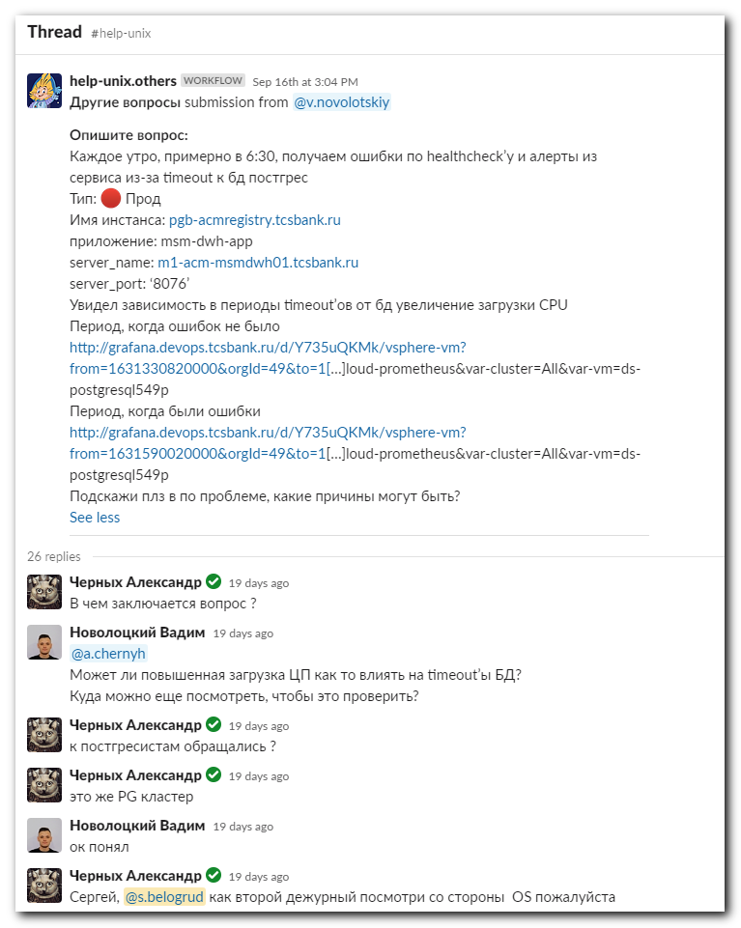
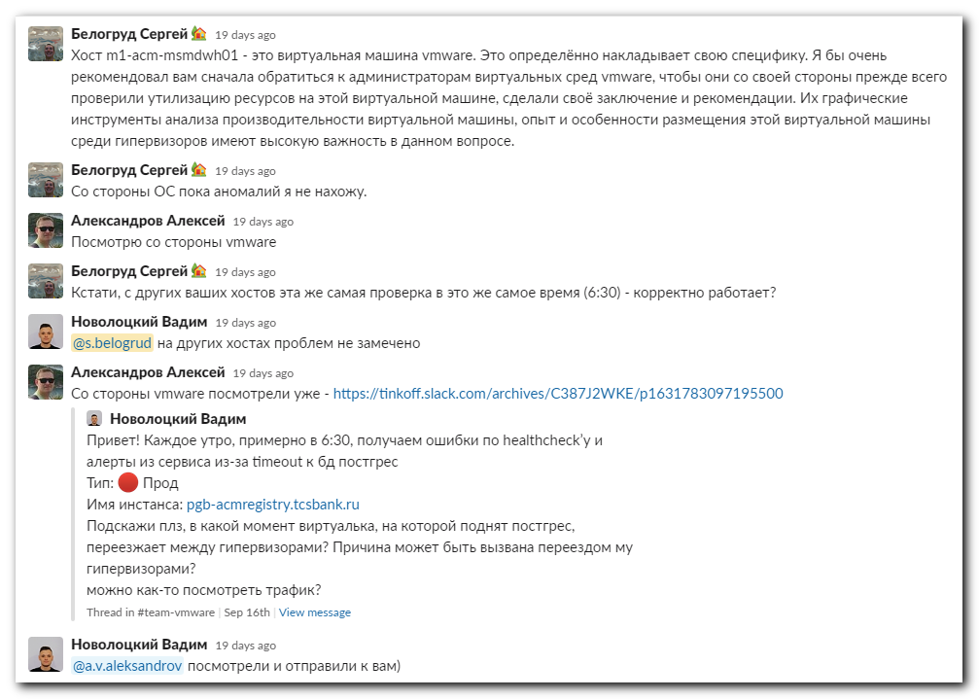
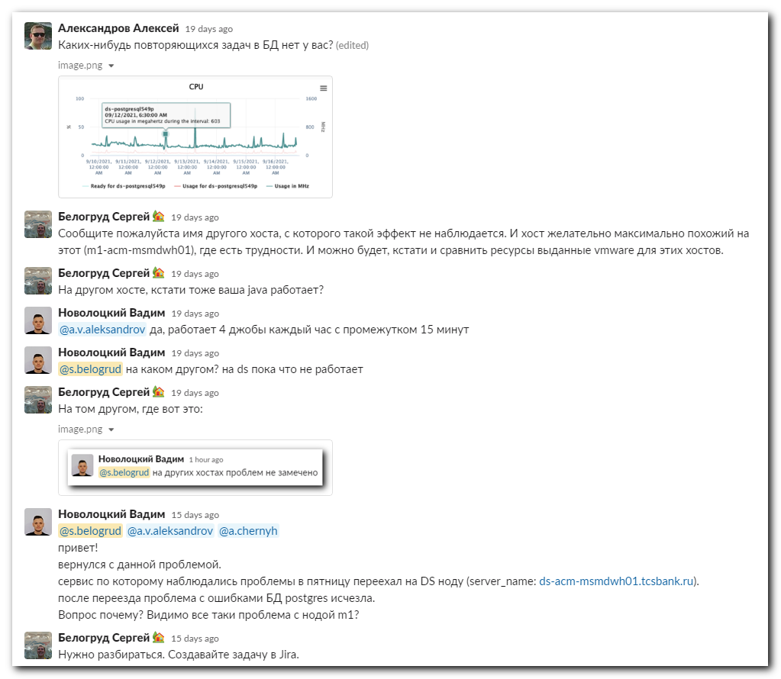
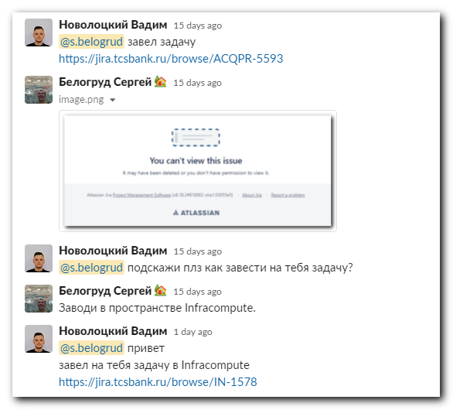

https://tinkoff.slack.com/archives/D3T62J36G/p1631803351000700
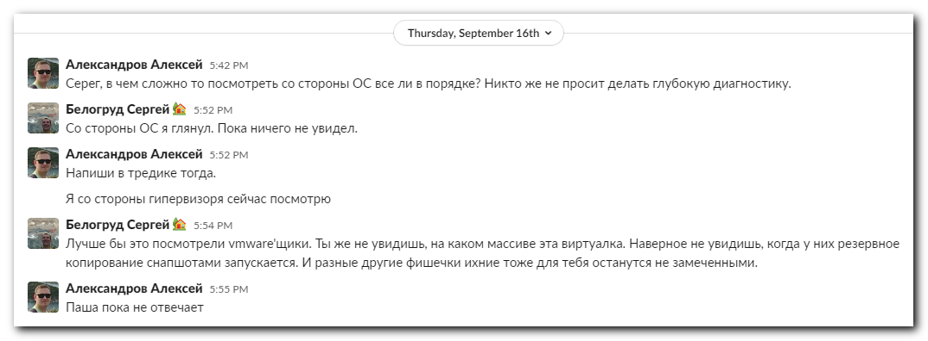

20211005
*. Jira. Задача "Timeout'ы к БД postgres" (https://jira.tcsbank.ru/browse/IN-1578) [Новолоцкий Вадим].
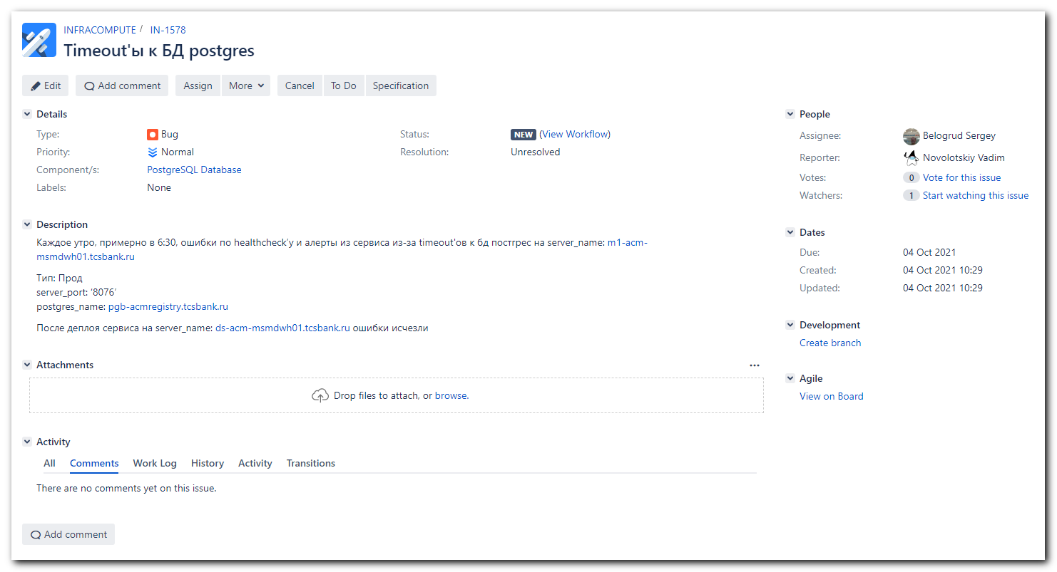

[root@m1-acm-msmdwh01 ~]# for var1 in {22..01} ; do echo "/var/log/messages-202109${var1}.gz" ; zegrep -e "06:30:[0-6][0-6]" -A 5 -B 5 /var/log/messages-202109${var1}.gz ; done

/var/log/messages-20210918.gz
Sep 17 06:25:01 m1-acm-msmdwh01 systemd: Started Session 198726 of user root.
Sep 17 06:26:01 m1-acm-msmdwh01 systemd: Started Session 198727 of user root.
Sep 17 06:27:01 m1-acm-msmdwh01 systemd: Started Session 198728 of user root.
Sep 17 06:28:01 m1-acm-msmdwh01 systemd: Started Session 198729 of user root.
Sep 17 06:29:01 m1-acm-msmdwh01 systemd: Started Session 198730 of user root.
Sep 17 06:30:01 m1-acm-msmdwh01 systemd: Started Session 198731 of user root.
Sep 17 06:30:24 m1-acm-msmdwh01 consul: 2021/09/17 06:30:24 [WARN] agent: Check "service:msm-dwh-app-8076" HTTP request failed: Get http://m1-acm-msmdwh01.tcsbank.ru:8076/actuator/health: net/http: request canceled (Client.Timeout exceeded while awaiting headers)
Sep 17 06:30:24 m1-acm-msmdwh01 consul[1069]: agent: Check "service:msm-dwh-app-8076" HTTP request failed: Get http://m1-acm-msmdwh01.tcsbank.ru:8076/actuator/health: net/http: request canceled (Client.Timeout exceeded while awaiting headers)
Sep 17 06:30:54 m1-acm-msmdwh01 consul: 2021/09/17 06:30:54 [WARN] agent: Check "service:msm-dwh-app-8076" HTTP request failed: Get http://m1-acm-msmdwh01.tcsbank.ru:8076/actuator/health: net/http: request canceled (Client.Timeout exceeded while awaiting headers)
Sep 17 06:30:54 m1-acm-msmdwh01 consul[1069]: agent: Check "service:msm-dwh-app-8076" HTTP request failed: Get http://m1-acm-msmdwh01.tcsbank.ru:8076/actuator/health: net/http: request canceled (Client.Timeout exceeded while awaiting headers)
Sep 17 06:31:01 m1-acm-msmdwh01 systemd: Started Session 198732 of user root.
Sep 17 06:31:14 m1-acm-msmdwh01 consul: 2021/09/17 06:31:14 [WARN] agent: Check "service:msm-dwh-app-8076" HTTP request failed: Get http://m1-acm-msmdwh01.tcsbank.ru:8076/actuator/health: net/http: request canceled (Client.Timeout exceeded while awaiting headers)
Sep 17 06:31:14 m1-acm-msmdwh01 consul[1069]: agent: Check "service:msm-dwh-app-8076" HTTP request failed: Get http://m1-acm-msmdwh01.tcsbank.ru:8076/actuator/health: net/http: request canceled (Client.Timeout exceeded while awaiting headers)
Sep 17 06:31:52 m1-acm-msmdwh01 consul: 2021/09/17 06:31:52 [WARN] agent: Check "service:msm-dwh-app-8076" HTTP request failed: Get http://m1-acm-msmdwh01.tcsbank.ru:8076/actuator/health: net/http: request canceled (Client.Timeout exceeded while awaiting headers)
Sep 17 06:31:52 m1-acm-msmdwh01 consul[1069]: agent: Check "service:msm-dwh-app-8076" HTTP request failed: Get http://m1-acm-msmdwh01.tcsbank.ru:8076/actuator/health: net/http: request canceled (Client.Timeout exceeded while awaiting headers)

/var/log/messages-20210917.gz
Sep 16 06:25:01 m1-acm-msmdwh01 systemd: Started Session 197250 of user root.
Sep 16 06:26:01 m1-acm-msmdwh01 systemd: Started Session 197251 of user root.
Sep 16 06:27:01 m1-acm-msmdwh01 systemd: Started Session 197252 of user root.
Sep 16 06:28:01 m1-acm-msmdwh01 systemd: Started Session 197253 of user root.
Sep 16 06:29:01 m1-acm-msmdwh01 systemd: Started Session 197254 of user root.
Sep 16 06:30:01 m1-acm-msmdwh01 systemd: Started Session 197255 of user root.
Sep 16 06:30:20 m1-acm-msmdwh01 consul: 2021/09/16 06:30:20 [WARN] agent: Check "service:msm-dwh-app-8076" HTTP request failed: Get http://m1-acm-msmdwh01.tcsbank.ru:8076/actuator/health: net/http: request canceled (Client.Timeout exceeded while awaiting headers)
Sep 16 06:30:20 m1-acm-msmdwh01 consul[1069]: agent: Check "service:msm-dwh-app-8076" HTTP request failed: Get http://m1-acm-msmdwh01.tcsbank.ru:8076/actuator/health: net/http: request canceled (Client.Timeout exceeded while awaiting headers)
Sep 16 06:30:40 m1-acm-msmdwh01 consul: 2021/09/16 06:30:40 [WARN] agent: Check "service:msm-dwh-app-8076" HTTP request failed: Get http://m1-acm-msmdwh01.tcsbank.ru:8076/actuator/health: net/http: request canceled (Client.Timeout exceeded while awaiting headers)
Sep 16 06:30:40 m1-acm-msmdwh01 consul[1069]: agent: Check "service:msm-dwh-app-8076" HTTP request failed: Get http://m1-acm-msmdwh01.tcsbank.ru:8076/actuator/health: net/http: request canceled (Client.Timeout exceeded while awaiting headers)
Sep 16 06:31:01 m1-acm-msmdwh01 systemd: Started Session 197256 of user root.
Sep 16 06:31:11 m1-acm-msmdwh01 consul: 2021/09/16 06:31:11 [WARN] agent: Check "service:msm-dwh-app-8076" HTTP request failed: Get http://m1-acm-msmdwh01.tcsbank.ru:8076/actuator/health: net/http: request canceled (Client.Timeout exceeded while awaiting headers)
Sep 16 06:31:11 m1-acm-msmdwh01 consul[1069]: agent: Check "service:msm-dwh-app-8076" HTTP request failed: Get http://m1-acm-msmdwh01.tcsbank.ru:8076/actuator/health: net/http: request canceled (Client.Timeout exceeded while awaiting headers)
Sep 16 06:31:31 m1-acm-msmdwh01 consul: 2021/09/16 06:31:31 [WARN] agent: Check "service:msm-dwh-app-8076" HTTP request failed: Get http://m1-acm-msmdwh01.tcsbank.ru:8076/actuator/health: net/http: request canceled (Client.Timeout exceeded while awaiting headers)
Sep 16 06:31:31 m1-acm-msmdwh01 consul[1069]: agent: Check "service:msm-dwh-app-8076" HTTP request failed: Get http://m1-acm-msmdwh01.tcsbank.ru:8076/actuator/health: net/http: request canceled (Client.Timeout exceeded while awaiting headers)

/var/log/messages-20210916.gz
Sep 15 06:25:01 m1-acm-msmdwh01 systemd: Started Session 195775 of user root.
Sep 15 06:26:01 m1-acm-msmdwh01 systemd: Started Session 195776 of user root.
Sep 15 06:27:01 m1-acm-msmdwh01 systemd: Started Session 195777 of user root.
Sep 15 06:28:01 m1-acm-msmdwh01 systemd: Started Session 195778 of user root.
Sep 15 06:29:01 m1-acm-msmdwh01 systemd: Started Session 195779 of user root.
Sep 15 06:30:01 m1-acm-msmdwh01 systemd: Started Session 195780 of user root.
Sep 15 06:30:31 m1-acm-msmdwh01 consul[1069]: agent: Check "service:msm-dwh-app-8076" HTTP request failed: Get http://m1-acm-msmdwh01.tcsbank.ru:8076/actuator/health: net/http: request canceled (Client.Timeout exceeded while awaiting headers)
Sep 15 06:30:31 m1-acm-msmdwh01 consul: 2021/09/15 06:30:31 [WARN] agent: Check "service:msm-dwh-app-8076" HTTP request failed: Get http://m1-acm-msmdwh01.tcsbank.ru:8076/actuator/health: net/http: request canceled (Client.Timeout exceeded while awaiting headers)
Sep 15 06:30:51 m1-acm-msmdwh01 consul[1069]: agent: Check "service:msm-dwh-app-8076" HTTP request failed: Get http://m1-acm-msmdwh01.tcsbank.ru:8076/actuator/health: net/http: request canceled (Client.Timeout exceeded while awaiting headers)
Sep 15 06:30:51 m1-acm-msmdwh01 consul: 2021/09/15 06:30:51 [WARN] agent: Check "service:msm-dwh-app-8076" HTTP request failed: Get http://m1-acm-msmdwh01.tcsbank.ru:8076/actuator/health: net/http: request canceled (Client.Timeout exceeded while awaiting headers)
Sep 15 06:31:01 m1-acm-msmdwh01 systemd: Started Session 195781 of user root.
Sep 15 06:31:23 m1-acm-msmdwh01 consul: 2021/09/15 06:31:23 [WARN] agent: Check "service:msm-dwh-app-8076" HTTP request failed: Get http://m1-acm-msmdwh01.tcsbank.ru:8076/actuator/health: net/http: request canceled (Client.Timeout exceeded while awaiting headers)
Sep 15 06:31:23 m1-acm-msmdwh01 consul[1069]: agent: Check "service:msm-dwh-app-8076" HTTP request failed: Get http://m1-acm-msmdwh01.tcsbank.ru:8076/actuator/health: net/http: request canceled (Client.Timeout exceeded while awaiting headers)
Sep 15 06:31:43 m1-acm-msmdwh01 consul: 2021/09/15 06:31:43 [WARN] agent: Check "service:msm-dwh-app-8076" HTTP request failed: Get http://m1-acm-msmdwh01.tcsbank.ru:8076/actuator/health: net/http: request canceled (Client.Timeout exceeded while awaiting headers)
Sep 15 06:31:43 m1-acm-msmdwh01 consul[1069]: agent: Check "service:msm-dwh-app-8076" HTTP request failed: Get http://m1-acm-msmdwh01.tcsbank.ru:8076/actuator/health: net/http: request canceled (Client.Timeout exceeded while awaiting headers)

/var/log/messages-20210915.gz
Sep 14 06:25:01 m1-acm-msmdwh01 systemd: Started Session 194299 of user root.
Sep 14 06:26:01 m1-acm-msmdwh01 systemd: Started Session 194300 of user root.
Sep 14 06:27:01 m1-acm-msmdwh01 systemd: Started Session 194301 of user root.
Sep 14 06:28:01 m1-acm-msmdwh01 systemd: Started Session 194302 of user root.
Sep 14 06:29:01 m1-acm-msmdwh01 systemd: Started Session 194303 of user root.
Sep 14 06:30:01 m1-acm-msmdwh01 systemd: Started Session 194304 of user root.
Sep 14 06:30:26 m1-acm-msmdwh01 consul[1069]: agent: Check "service:msm-dwh-app-8076" HTTP request failed: Get http://m1-acm-msmdwh01.tcsbank.ru:8076/actuator/health: net/http: request canceled (Client.Timeout exceeded while awaiting headers)
Sep 14 06:30:26 m1-acm-msmdwh01 consul: 2021/09/14 06:30:26 [WARN] agent: Check "service:msm-dwh-app-8076" HTTP request failed: Get http://m1-acm-msmdwh01.tcsbank.ru:8076/actuator/health: net/http: request canceled (Client.Timeout exceeded while awaiting headers)
Sep 14 06:30:46 m1-acm-msmdwh01 consul: 2021/09/14 06:30:46 [WARN] agent: Check "service:msm-dwh-app-8076" HTTP request failed: Get http://m1-acm-msmdwh01.tcsbank.ru:8076/actuator/health: net/http: request canceled (Client.Timeout exceeded while awaiting headers)
Sep 14 06:30:46 m1-acm-msmdwh01 consul[1069]: agent: Check "service:msm-dwh-app-8076" HTTP request failed: Get http://m1-acm-msmdwh01.tcsbank.ru:8076/actuator/health: net/http: request canceled (Client.Timeout exceeded while awaiting headers)
Sep 14 06:31:01 m1-acm-msmdwh01 systemd: Started Session 194305 of user root.
Sep 14 06:31:06 m1-acm-msmdwh01 consul[1069]: agent: Check "service:msm-dwh-app-8076" HTTP request failed: Get http://m1-acm-msmdwh01.tcsbank.ru:8076/actuator/health: net/http: request canceled (Client.Timeout exceeded while awaiting headers)
Sep 14 06:31:06 m1-acm-msmdwh01 consul: 2021/09/14 06:31:06 [WARN] agent: Check "service:msm-dwh-app-8076" HTTP request failed: Get http://m1-acm-msmdwh01.tcsbank.ru:8076/actuator/health: net/http: request canceled (Client.Timeout exceeded while awaiting headers)
Sep 14 06:31:26 m1-acm-msmdwh01 consul: 2021/09/14 06:31:26 [WARN] agent: Check "service:msm-dwh-app-8076" HTTP request failed: Get http://m1-acm-msmdwh01.tcsbank.ru:8076/actuator/health: net/http: request canceled (Client.Timeout exceeded while awaiting headers)
Sep 14 06:31:26 m1-acm-msmdwh01 consul[1069]: agent: Check "service:msm-dwh-app-8076" HTTP request failed: Get http://m1-acm-msmdwh01.tcsbank.ru:8076/actuator/health: net/http: request canceled (Client.Timeout exceeded while awaiting headers)

/var/log/messages-20210914.gz
Sep 13 06:25:01 m1-acm-msmdwh01 systemd: Started Session 192824 of user root.
Sep 13 06:26:01 m1-acm-msmdwh01 systemd: Started Session 192825 of user root.
Sep 13 06:27:01 m1-acm-msmdwh01 systemd: Started Session 192826 of user root.
Sep 13 06:28:01 m1-acm-msmdwh01 systemd: Started Session 192827 of user root.
Sep 13 06:29:01 m1-acm-msmdwh01 systemd: Started Session 192828 of user root.
Sep 13 06:30:01 m1-acm-msmdwh01 systemd: Started Session 192829 of user root.
Sep 13 06:30:22 m1-acm-msmdwh01 consul[1069]: agent: Check "service:msm-dwh-app-8076" HTTP request failed: Get http://m1-acm-msmdwh01.tcsbank.ru:8076/actuator/health: net/http: request canceled (Client.Timeout exceeded while awaiting headers)
Sep 13 06:30:22 m1-acm-msmdwh01 consul: 2021/09/13 06:30:22 [WARN] agent: Check "service:msm-dwh-app-8076" HTTP request failed: Get http://m1-acm-msmdwh01.tcsbank.ru:8076/actuator/health: net/http: request canceled (Client.Timeout exceeded while awaiting headers)
Sep 13 06:30:53 m1-acm-msmdwh01 consul: 2021/09/13 06:30:53 [WARN] agent: Check "service:msm-dwh-app-8076" HTTP request failed: Get http://m1-acm-msmdwh01.tcsbank.ru:8076/actuator/health: net/http: request canceled (Client.Timeout exceeded while awaiting headers)
Sep 13 06:30:53 m1-acm-msmdwh01 consul[1069]: agent: Check "service:msm-dwh-app-8076" HTTP request failed: Get http://m1-acm-msmdwh01.tcsbank.ru:8076/actuator/health: net/http: request canceled (Client.Timeout exceeded while awaiting headers)
Sep 13 06:31:02 m1-acm-msmdwh01 systemd: Started Session 192830 of user root.
Sep 13 06:31:13 m1-acm-msmdwh01 consul: 2021/09/13 06:31:13 [WARN] agent: Check "service:msm-dwh-app-8076" HTTP request failed: Get http://m1-acm-msmdwh01.tcsbank.ru:8076/actuator/health: net/http: request canceled (Client.Timeout exceeded while awaiting headers)
Sep 13 06:31:13 m1-acm-msmdwh01 consul[1069]: agent: Check "service:msm-dwh-app-8076" HTTP request failed: Get http://m1-acm-msmdwh01.tcsbank.ru:8076/actuator/health: net/http: request canceled (Client.Timeout exceeded while awaiting headers)
Sep 13 06:31:53 m1-acm-msmdwh01 consul[1069]: agent: Check "service:msm-dwh-app-8076" HTTP request failed: Get http://m1-acm-msmdwh01.tcsbank.ru:8076/actuator/health: net/http: request canceled (Client.Timeout exceeded while awaiting headers)
Sep 13 06:31:53 m1-acm-msmdwh01 consul: 2021/09/13 06:31:53 [WARN] agent: Check "service:msm-dwh-app-8076" HTTP request failed: Get http://m1-acm-msmdwh01.tcsbank.ru:8076/actuator/health: net/http: request canceled (Client.Timeout exceeded while awaiting headers)

/var/log/messages-20210913.gz
Sep 12 06:29:08 m1-acm-msmdwh01 consul[1069]: agent: Check "service:msm-dwh-app-8076" HTTP request failed: Get http://m1-acm-msmdwh01.tcsbank.ru:8076/actuator/health: net/http: request canceled (Client.Timeout exceeded while awaiting headers)
Sep 12 06:29:28 m1-acm-msmdwh01 consul: 2021/09/12 06:29:28 [WARN] agent: Check "service:msm-dwh-app-8076" HTTP request failed: Get http://m1-acm-msmdwh01.tcsbank.ru:8076/actuator/health: net/http: request canceled (Client.Timeout exceeded while awaiting headers)
Sep 12 06:29:28 m1-acm-msmdwh01 consul[1069]: agent: Check "service:msm-dwh-app-8076" HTTP request failed: Get http://m1-acm-msmdwh01.tcsbank.ru:8076/actuator/health: net/http: request canceled (Client.Timeout exceeded while awaiting headers)
Sep 12 06:29:48 m1-acm-msmdwh01 consul[1069]: agent: Check "service:msm-dwh-app-8076" HTTP request failed: Get http://m1-acm-msmdwh01.tcsbank.ru:8076/actuator/health: net/http: request canceled (Client.Timeout exceeded while awaiting headers)
Sep 12 06:29:48 m1-acm-msmdwh01 consul: 2021/09/12 06:29:48 [WARN] agent: Check "service:msm-dwh-app-8076" HTTP request failed: Get http://m1-acm-msmdwh01.tcsbank.ru:8076/actuator/health: net/http: request canceled (Client.Timeout exceeded while awaiting headers)
Sep 12 06:30:01 m1-acm-msmdwh01 systemd: Started Session 191353 of user root.
Sep 12 06:30:08 m1-acm-msmdwh01 consul: 2021/09/12 06:30:08 [WARN] agent: Check "service:msm-dwh-app-8076" HTTP request failed: Get http://m1-acm-msmdwh01.tcsbank.ru:8076/actuator/health: net/http: request canceled (Client.Timeout exceeded while awaiting headers)
Sep 12 06:30:08 m1-acm-msmdwh01 consul[1069]: agent: Check "service:msm-dwh-app-8076" HTTP request failed: Get http://m1-acm-msmdwh01.tcsbank.ru:8076/actuator/health: net/http: request canceled (Client.Timeout exceeded while awaiting headers)
Sep 12 06:30:28 m1-acm-msmdwh01 consul: 2021/09/12 06:30:28 [WARN] agent: Check "service:msm-dwh-app-8076" HTTP request failed: Get http://m1-acm-msmdwh01.tcsbank.ru:8076/actuator/health: net/http: request canceled (Client.Timeout exceeded while awaiting headers)
Sep 12 06:30:28 m1-acm-msmdwh01 consul[1069]: agent: Check "service:msm-dwh-app-8076" HTTP request failed: Get http://m1-acm-msmdwh01.tcsbank.ru:8076/actuator/health: net/http: request canceled (Client.Timeout exceeded while awaiting headers)
Sep 12 06:30:48 m1-acm-msmdwh01 consul: 2021/09/12 06:30:48 [WARN] agent: Check "service:msm-dwh-app-8076" HTTP request failed: Get http://m1-acm-msmdwh01.tcsbank.ru:8076/actuator/health: net/http: request canceled (Client.Timeout exceeded while awaiting headers)

Oct 5, 2021
# I inserted the first line. It was absent.
# 10.212.10.67 m1-acm-msmdwh01.tcsbank.ru m1-acm-msmdwh01

[root@m1-acm-msmdwh01 ~]# vim /etc/hosts
[root@m1-acm-msmdwh01 ~]# cat /etc/hosts
10.212.10.67 m1-acm-msmdwh01.tcsbank.ru m1-acm-msmdwh01
127.0.0.1 localhost localhost.localdomain localhost4 localhost4.localdomain4
[root@m1-acm-msmdwh01 ~]#

